Graphing Services
Chapter
6

Introduction
The Graphing Services package provides services for creating graphs and charts.

Requirements
XY Graphs
Automatic unit conversions

Logical Design

Static Models

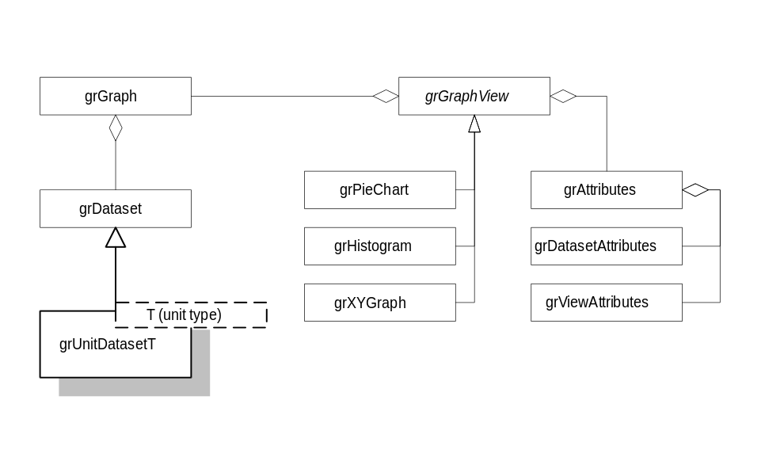

Dynamic Models

Physical Design

Specifications

grDataSet
A collection of data that is to be represented with a graph.

Public Interface - Member Functions
AddValue
virtual void AddValue(Float64 v);
Adds a value to the data set.
GetValue
virtual Float64 GetValue(Uint32 i) const;
Returns the i^{th} value from the data set
GetMinValue
virtual Float64 GetMinValue() const;
Returns the minimum value from the data set.
GetMaxValue
virtual Float64 GetMaxValue() const;
Returns the maximum value from the data set.
GetValueRange
virtual Float64 GetValueRange() const;
Returns max value - min value.
Size
Uint32 Size() const;
Returns the size of the data set.

template <class T> grUnitDataSetT
Derived from grDataSet, this class provides automatic unit conversion capabilities for data set values. Values are provided to the data set in system units and they are represented in a graph in the unit of measure associated with this data set.

Public Interface - Member Functions
AddValue
virtual void AddValue(Float64 v);
Overrides the base class implementation by converting v from system units to the unit of measure associated with this data set.
SetUnitOfMeasure
void SetUnitOfMeasure(const T* pUnitOfMeasure);
Sets the unit of measure for this data set. The stored units of measure are converted.
GetUnitOfMeasure
const T& GetUnitOfMeasure() const;
Returns a reference to the unit of measure.

grDataSetIterator
Iterates threw the values in a data set. This class will implement the standard iterator methods First(), Last(), Next(), Prev(), Move(), MoveBy(), and IsDone(). The standard GetCurrent() iterator method for this class is described below.

Public Interface - Member Functions
GetCurrentValue
Float64 GetCurrentValue() const;
Returns the current value.
GetCurrentIndex
Uint32 GetCurrentIndex() const;
Returns the current index.

grGraph
A graph is a collection of related data sets that are to be displayed together. A graph is a model in the MVC sense.
Need some subject-observer functionality between the dataset and the graph and between the graph it is views.

Public Interface - Member Functions
AddDataset
Int32 AddDataset(const grDataset* pDataset);
Adds a data set to the graph.
GetDataset
const grDataset& GetDataset(Int32 key) const;
grDataset& GetDataset(Int32 key);
Returns a reference to the data set identified by key.
RemoveDataset
grDataset* RemoveDataset(Int32 key)
Removes the dataset identified by key from the graph. Releases ownership of the data set to the caller. Returns a pointer to the data set. If the data set could not be found, 0 is returned.
SetTitle
void SetTitle(const std::string& title);
Sets the graph title.
GetTitle
std::string GetTitle() const;
Returns the graph title.
SetSubtitle
void SetSubtitle(const std::string& title);
Sets the graph subtitle.
GetSubtitle
std::string GetSubtitle() const;
Returns the graph subtitle.

grGraphView
Abstract base class for a graph view(MVC).

Public Interface - Member Functions
SetGraph
void SetGraph(const grGraph* pGraph);
Associates a graph with this view
GetGraph
const grGraph* GetGraph() const;
grGraph* GetGraph();
Returns a pointer to the graph associated with this view. Returns 0 if a graph hasn’t been associated yet.

Protected Interface - Member Functions
OnDatasetChanged
virtual void OnDatasetChanged(Int32 key);
Called when the data set identified by key has changed. Derived classes should override this method to provide a meaningful implementation.

grPieChart
Derived from grGraphView, objects of this class display a data set as a pie chart. The pie chart view can only draw on pie chart at a time. Since a graph can have multiple data sets, a data set will have to be selected.
Specification is for illustrative purposes. It isn’t necessary to implement this class at present.

Public Interface - Member Functions
SetDataset
bool SetDataset(Int32 key);
Sets the data set that will be represented with a pie chart. If the data set identified by key cannot be found, the first data set in the graph will be used. Returns true if the requested data set was found, otherwise false.
GetDataset
Int32 GetDataset() const;
Returns the key for the data set that is being represented with this pie chart.
Function
void Signature();
Other methods that apply to pie charts. This might include exploding a pie slice, rendering modes such as 3D, showing pie slices as percentages, etc.

grHistogram
Derived from grGraphView, objects of this class display data sets as histograms.
Specification is for illustrative purposes. It isn’t necessary to implement this class at present.

Public Interface - Member Functions
Function
void Signature();
Methods that apply to histograms.

grXYView
Derived from grGraphView, objects of this class display data sets as X-Y graphs. X-Y graphs can be represented as independent values or dependent values.

Independent value X-Y Graphs
All data sets are considered to be Y values, independent of one another. The X axis consists of integer values ranging from one to the size of the largest data set in the graph. The first value in the data set is plotted against the X value 1, the second value is plotted against 2, etc.

Dependent value X-Y Graphs
All but one data sets are considered to be Y values. One data set contains the independent variable X and the remaining data sets contain the dependent variable Y. If a dependent data set has more values than the independent data set, the extra values are ignored. If the independent data set has more values than the dependent data sets, the range of the independent variable is limited to the number of values in the largest dependent data set.

Public Interface - Member Functions
SetDependentDataset
void SetDependentDataset(Int32 key);
Sets the dependent data set. If the data set identified by key cannot be found, the first data set in the graph is used as the dependent data set. Returns true if the requested data set was found, otherwise false.
GetDependentDataset
Int32 GetDependentDataset() const;
Returns the dependent data set key.
ClearDependentDataset
void ClearDependentDataset();
Clears the dependent data set. Changes to the independent value graph mode.
Function
void Signature();
Other X-Y graph related functions like, axis range, tick marks, tick mark types, labels, axis modes (logarithmic), symbols on or off, legends, etc.

grDatasetAttributes
Represents the visual attributes associated with a data set such as color, line weight, symbols, font face, font pitch, etc.

Public Interface - Member Functions
Function
void Signature();
Set/Get methods for the various attributes.

grViewAttributes
Represents the visual attributes associated with a graph view such as font face and pitch for titles and subtitles, legend formatting, etc.

Public Interface - Member Functions
Function
void Signature();
Set/Get methods for the various attributes.

grAttributes
Encapsulates graph view and data set attributes into a single object that can easily be shared between different view types.

Public Interface - Member Functions
Function
void Signature();
Set/Get methods for managing attributes.

